Specifications
  - KUH-RPf-0020 Shadow postings Consi external storage area Stock receiving storage area portal
Doc Version 1.0

Customer: | Kunststoff Helmbrechts AG
Project: | Plastic Helmbrechts Update 9.5.3
Proalpha version: | 9.5.3
Proalpha installation(s): | DE
Product variant: | ☒ Proalpha ray  ☒ Proalpha classic  Note: If "Proalpha ray" is checked, the following is also done Always a conversion in the classic client.
GUI language: | German
Author: | Marcel Grüneberg
Created on: | 02.06.2026
Last change on: | 05.06.2026
Contact person customer: | Jörg Köhler

This document describes a customization or extension of the standard software in Proalpha in the product variant defined above and has been checked by the customer. The technical design in Chapters 2 - 4 is hereby released in compliance with the requirements of the "Final Provisions" section of the technical specification and costing:

.............................................
Date and signature customer

Contents
1. [UPDATE THE TABLE] 4
1.1 [UPDATE THE TABLE] 4
1.2 [UPDATE THE TABLE] 4
2. [UPDATE THE TABLE] 5
2.1 [UPDATE THE TABLE] 5
2.1.1 [UPDATE THE TABLE] 5
2.2 [UPDATE THE TABLE] 5
2.2.1 [UPDATE THE TABLE] 5
2.3 [UPDATE THE TABLE] 7
3. [UPDATE THE TABLE] 9
3.1 [UPDATE THE TABLE] 9
3.1.1 [UPDATE THE TABLE] 9
3.1.2 [UPDATE THE TABLE] 9
3.2 [UPDATE THE TABLE] 9
3.2.1 [UPDATE THE TABLE] 10
3.2.2 [UPDATE THE TABLE] 10
3.3 [UPDATE THE TABLE] 10
3.3.1 [UPDATE THE TABLE] 11
3.3.2 [UPDATE THE TABLE] 11
3.4 [UPDATE THE TABLE] 11
3.4.1 [UPDATE THE TABLE] 12
3.4.2 [UPDATE THE TABLE] 12
3.5 [UPDATE THE TABLE] 12
3.5.1 [UPDATE THE TABLE] 13
3.5.2 [UPDATE THE TABLE] 13
3.6 [UPDATE THE TABLE] 13
3.6.1 [UPDATE THE TABLE] 14
3.6.2 [UPDATE THE TABLE] 14
4. [UPDATE THE TABLE] 15
4.1 [UPDATE THE TABLE] 15
4.2 [UPDATE THE TABLE] 15
4.3 [UPDATE THE TABLE] 15
5. [UPDATE THE TABLE] 16
5.1 [UPDATE THE TABLE] 16
5.1.1 [UPDATE THE TABLE] 16
5.1.2 [UPDATE THE TABLE] 16
5.1.3 [UPDATE THE TABLE] 16
6. [UPDATE THE TABLE] 17
7. [UPDATE THE TABLE] 18
7.1 [UPDATE THE TABLE] 18
7.2 [UPDATE THE TABLE] 18
8. [UPDATE THE TABLE] 19

Requirements

References
- Workshop "Adaptation Modifications" on 11.05.2026
- KUH-JSN-A024-Shadow Postings Consignment External Storage Area

Summary and objective
With KUH-JSN-A024-Shadow Postings Consi-External Storage Area, a function has been provided which, when a shipping document to warehouse is received, automatically performs a posting to the external storage area in the corresponding company. This function is also to be provided for the stock receiving in the storage area portal. Furthermore, the expiration date of the lot is to be adopted from the source company when a lot is created in the corresponding company.

Professional design

Stock receiving shipping document to warehouse

Business logic & GUI
With KUH-JSN-A024-Shadow Postings Consi-External Storage Area, a shadow posting has been implemented in the external storage area of the target company. The trigger is the stock receiving of a shipping document to warehouse if corresponding control data for the shadow posting have been defined (record in table X_KonsiExt_Steuerung for the part). For lot-controlled parts, a lot is already created in the target company if it does not exist yet. This is to be extended in such a way that the expiration date of the lot is adopted from the source company into the lot of the target company if the "Expiration Date" indicator is set to "Yes" in the lot category of the part in the target company (MC_Art.Expiration Date = yes).
Note for the development: The creation of the lot is currently marked with the remark "Automatic Creation SDW". This information should assist in the determination of the relevant bit of code.
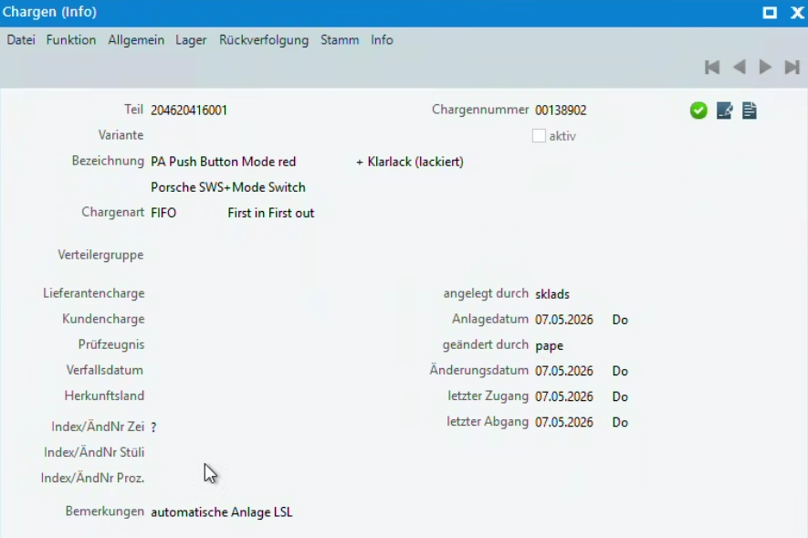
Figure: 1Lots - Remark if lot has been automatically created (for information purposes only - no extension)

Stock receiving shipping document to warehouse in b2b warehouse portal

Business logic & interface
The KUH-JSN-A024-Shadow Postings Consi External Storage Area modification is currently only available if the stock receiving posting of the shipping document to warehouse is performed in the Proalpha client. In the future, the shadow posting is also to be performed when the stock receiving of the shipping document to warehouse is performed in the b2b warehouse portal. The functionality and error handling have to be designed analogously to the function in the Proalpha client.

For information purposes, here are the relevant calls:
Proalpha client
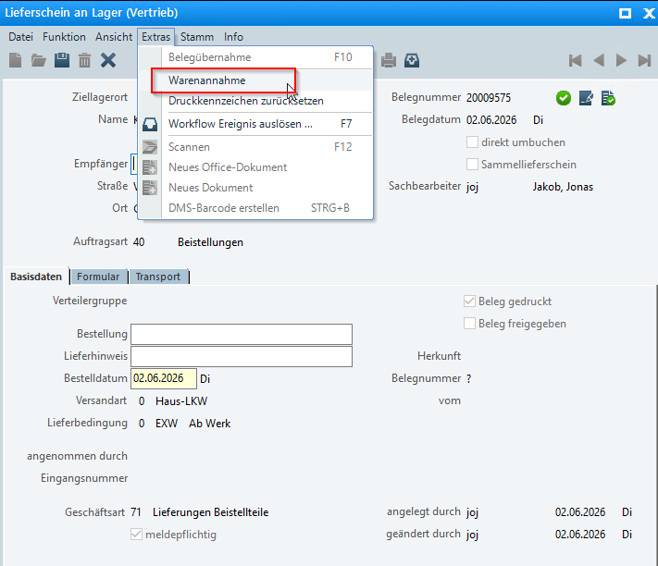
Figure: 2Shipping document to warehouse stock receiving (Info only - no extension)

B2b warehouse portal
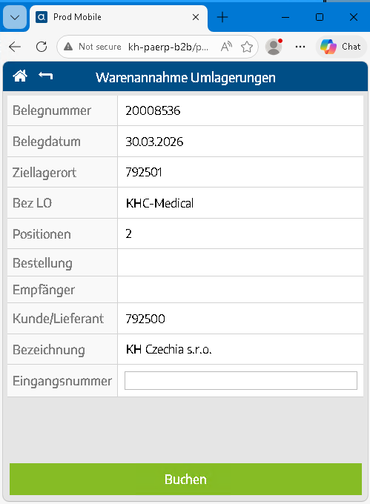
Figure: 3Shipping document to warehouse - stock receiving in the b2b warehouse portal

Accruals and deferrals
The adjustment applies to the tables, fields and programs mentioned.
This specification does not automatically add functional extensions to the adjacent modules of the Environment Proalpha , such as DMS, Analyzer, reports and forms. The Help Proalpha is not automatically expanded.
Changes to adjoining modules/programs must be described and defined in the functional specification. It also includes changes to the GUI. If Ray is not explicitly mentioned here, the present customization refers to the Classic Proalpha client.

Test cases

Shadow posting during stock receiving in the b2b storage area portal - positive case

Explanation | Test data | Expected result
1. Ensure that there is a record for the part to be tested in the X_KonsiExt_Steuerung table in the source company (control data for shadow posting defined).  2. Calling up a shipping document to warehouse in the b2b warehouse portal for which a stock receiving is to be performed.  3. Perform the stock receiving of the shipping document to warehouse in the b2b warehouse portal (analogous to Figure 3 in the functional specification).  4. After the stock receiving has been completed in the target company, check whether an automatic shadow posting has been performed in the external storage area of the target company. | - Part with existing record in X_KonsiExt_Steuerung  - Valid shipping document to warehouse in b2b warehouse portal  - Source company and target company configured correctly | - The stock receiving in the b2b storage area portal is completed successfully.  - In the target company, a shadow posting to the external storage area is automatically performed, analogous to the functionality in the Proalpha client.  - No error message is displayed.

Screenshot Proalpha

Customer Screenshots

Shadow posting during stock receiving in the b2b storage area portal - no control record available

Explanation | Test data | Expected result
1. Ensure that THERE IS NO record in the X_KonsiExt_Steuerung table in the source company for the part to be tested.  2. Calling up a shipping document to warehouse in the b2b warehouse portal for which a stock receiving is to be performed.  3. Executing the stock receiving of the shipping document to warehouse in the b2b warehouse portal.  4. After the stock receiving has been completed in the target company, check whether a shadow posting has been performed in the external storage area. | - Part WITHOUT record in X_KonsiExt_Steuerung  - Valid shipping document to warehouse in b2b warehouse portal | - The stock receiving in the b2b storage area portal is completed successfully.  - NO shadow posting is performed at the external storage area of the target company since no control data have been defined.

Screenshot Proalpha

Customer Screenshots

Handling errors during a shadow posting in the b2b warehouse portal - analogy to the Proalpha client

Explanation | Test data | Expected result
1. Ensure that there is a record in the X_KonsiExt_Steuerung table for the part to be tested.  2. Create an error situation that would cause the shadow posting on the Proalpha client to fail (for example, the target company has a missing or inconsistent configuration).  3. Executing the stock receiving of the respective shipping document to warehouse in the b2b warehouse portal.  4. Monitor the behavior of the system and the displayed error message in the b2b warehouse portal and compare it to the known error handling in the Proalpha client. | - Part with record in X_KonsiExt_Steuerung  - Incorrectly configured target company (e.g. missing configuration for shadow posting) | - The error handling in the b2b warehouse portal behaves analogously to the error handling in the Proalpha client.  - A corresponding error message is displayed to the user.  - The system behaves consistently with the Proalpha client.

Screenshot Proalpha

Customer Screenshots

Adoption of expiration date for automatic lot creation in target company - expiration date enabled

Explanation | Test data | Expected result
1. Ensure that the part to be tested is lot-controlled and that a record is available in X_KonsiExt_Steuerung.  2. Ensure that the "Expiration Date" indicator is set to "Yes" in the lot category of the part in the target company (MC_Art.Expiration Date = yes).  3. Creating a lot for the part with a defined expiration date in the source company or ensuring that such a lot is available.  4. Perform the stock receiving of a shipping document to warehouse for this part and lot on the Proalpha client.  5. Check in the target company whether the lot has been automatically created ("Automatic Creation SDW Available" remark).  6. Check the expiration date of the automatically created lot in the target company and compare it with the expiration date of the lot in the source company. | - Lot-controlled part with record in X_KonsiExt_Steuerung  - Lot category in the target company: MC_Art.Expiration date = yes  - Lot in the source company with defined expiration date (e.g. 31.12.2026)  - Valid shipping document to warehouse on the Proalpha client | - The stock receiving is completed successfully.  - The lot is automatically created in the target company ("Automatic Creation SDW" remark available).  - The expiration date of the lot in the target company corresponds to the expiration date of the lot from the source company (e.g. 31.12.2026).

Screenshot Proalpha

Customer Screenshots

Adoption of expiration date for automatic lot creation in target company - expiration date disabled

Explanation | Test data | Expected result
1. Ensure that the part to be tested is lot-controlled and that a record is available in X_KonsiExt_Steuerung.  2. Ensure that the "Expiration Date" indicator is set to "No" in the lot category of the part in the target company (MC_Art.Expiration Date = no).  3. Creating a lot for the part with a defined expiration date in the source company or ensuring that such a lot is available.  4. Perform the stock receiving of a shipping document to warehouse for this part and lot on the Proalpha client.  5. Check in the target company whether the lot has been automatically created ("Automatic Creation SDW Available" remark).  6. Check the expiration date of the automatically created lot in the target company. | - Lot-controlled part with record in X_KonsiExt_Steuerung  - Lot category in the target company: MC_Art.Expiration date = no  - Lot in the source company with defined expiration date  - Valid shipping document to warehouse on the Proalpha client | - The stock receiving is completed successfully.  - The lot is automatically created in the target company ("Automatic Creation SDW" remark available).  - The expiration date from the source company is NOT adopted into the lot of the target company since MC_Art.Expiration date = no.

Screenshot Proalpha

Customer Screenshots

Adopting the expiration date for entering lots via stock receiving in the b2b storage area portal

Explanation | Test data | Expected result
1. Ensure that the part to be tested is lot-controlled and that a record is available in X_KonsiExt_Steuerung.  2. Ensure that the "Expiration Date" indicator is set to "Yes" in the lot category of the part in the target company (MC_Art.Expiration Date = yes).  3. Creating a lot for the part with a defined expiration date in the source company or ensuring that such a lot is available and the lot is NOT yet available in the target company.  4. Perform the stock receiving of the shipping document to warehouse for this part and lot in the b2b warehouse portal (analogous to Figure 3 in the functional specification).  5. Check in the target company whether the lot has been automatically created ("Automatic Creation SDW Available" remark).  6. Check the expiration date of the automatically created lot in the target company and compare it with the expiration date of the lot in the source company. | - Lot-controlled part with record in X_KonsiExt_Steuerung  - Lot category in the target company: MC_Art.Expiration date = yes  - Lot in the source company with defined expiration date (e.g. 31.12.2026)  - Lot not yet available in the target company  - Valid shipping document to warehouse in b2b warehouse portal | - The stock receiving in the b2b storage area portal is completed successfully.  - The lot is automatically created in the target company ("Automatic Creation SDW" remark available).  - The expiration date of the lot in the target company corresponds to the expiration date of the lot from the source company (e.g. 31.12.2026).  - The shadow posting to the external storage area of the target company is correctly performed.

Screenshot Proalpha

Customer Screenshots

Prerequisites

Technical requirements
The use of Proalpha functionalities outside the Concurrent User Model (connection of external systems, background processing) requires the license of so-called software services.
"Use of Proalpha functionalities" refers to any use or access to the Proalpha infrastructure, e.g.
- Writing to data structures of Proalpha
- Calling Proalpha classes and other business logic
- Calling Proalpha services
The following software services are therefore required for the implementation described in the functional specification:
- B2b services

Organizational requirements

Notes about placing in operation

Technical design

<Template for Section>

GUI

Business logic

Data model

Final provisions
This specification is the basis for customer-specific expansions of the standard software Proalpha ®.
The customer-specific expansions only cover the category defined in this specification. Functionality beyond this scope is not provided.
Unless expressly agreed otherwise, the customer-specific extensions are only created in German: no programs, program parts or data are translated into other languages. This also applies to the languages supported by Proalpha ® in the standard version.
The customer-specific extensions are carefully tested before delivery. However, for technical reasons, it is not possible to perform the test under the same conditions and with the same data that will be used at the customer's. It is therefore recommended to carefully check the functions in the real system environment after they have been delivered.
The Customer is aware that variances in the display details or handling may be required for the transfer of the functionalities defined in this functional specification to new versions of Proalpha ®. This specification also remains valid in this case, provided that there is an update agreement for the customer-specific extensions defined in this specification and no changes to the functionality have to be agreed on.
This specification documents the customer-specific expansions. No other documentation shall be provided in addition to that contained in this specification. Questions about customer-specific expansions are received and forwarded by the hotline.
By signing on page 1, you confirm that
- that the functional specification is accepted in this version and becomes part of the contract,
- that this specification defines the functional scope of the software to be created and that there are no side agreements regarding the functionality,
- a technical specification is created for the functional specification, which is separately invoiced if the quote is not ordered in the context of the quote validity for the implementation of the functional specification.

Appendix

Table of Figures
[UPDATE THE TABLE] 5
[UPDATE THE TABLE] 6
[UPDATE THE TABLE] 7

Table of tables
No entries could be found for a table of figures.

Change history
Doc. -  Version | Date | Specialist | initiator | Chapter | Explanation
1.0 | 05.06.2026 | Marcel Grüneberg | Jörg Köhler | All | Initial new entry

